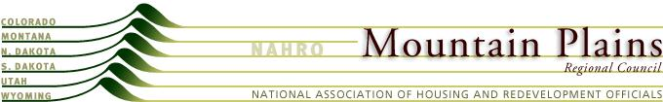

Mountain Plains NAHRO

Resolution
Regarding the Re-structuring of Conference Registration Fees
October 30, 2013
WHEREAS, part of NAHRO’s stated mission is to ensure that housing and community development professionals have the leadership skills, education, information and tools to serve communities in a rapidly changing environment;
WHEREAS, NAHRO seeks the active involvement of all sizes of agencies to participate in national committees and trainings that take place at all NAHRO conferences;
WHEREAS, budget pressures involving administrative and operational funds are disproportionately affecting small and medium housing and community development agencies;
NOW THEREFORE BE IT RESOLVED that the Mountain Plains Regional Council proposes that NAHRO evaluate the re-structuring of its conference registration fees so that an agency’s ability to pay is taken into consideration. One possible approach would be to structure conference registration fees based on the combined number of units an agency manages similar to the membership dues formula. MPRC believes that such a re-structuring would allow greater participation from small and medium sized agencies while not significantly impacting larger agencies resulting in an overall increase in conference attendance.

