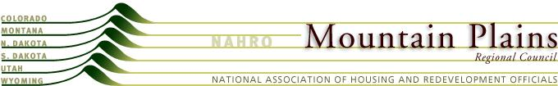

Mountain Plains NAHRO

Resolution
Regarding the Establishment of the Legislative Network Committee as a National Standing Committee
March 6, 2013
WHEREAS, one of NAHRO’s primary core missions is to advocate for appropriate laws, adequate funding levels and responsible public policies that address the needs of the people served; are financially and programmatically viable for our industry; are flexible, reduce regulatory burdens and promote local decision-making and
WHEREAS, it is becoming increasingly critical to effectively communicate to members of Congress the vital importance of our Programs to the maintenance of strong and healthy communities and
WHEREAS, in the current climate of budget cutting NAHRO needs to take a an even more active role in creating legislation to safeguard and expand the programs that support affordable housing and community development and
WHEREAS, the present status of the Legislative Network Committee does not allow for a full day of meetings during NAHRO conferences as is provided to the National Standing Committees and
WHEREAS, a large percentage of the Legislative Network Committee membership is comprised of individuals already participating on National Standing Committees, therefore potentially diluting the effectiveness and amount of time commitment these volunteers can provide.
NOW THEREFORE BE IT RESOLVED that the Mountain Plains Regional Council proposes that the NAHRO Constitution be amended to make the Legislative Network Committee a National Standing Committee.

