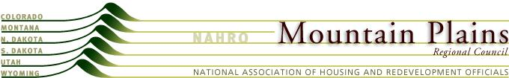

Mountain Plains NAHRO

Resolution
Regarding Expansion Opportunities for New Members
February 2014
WHEREAS, NAHRO is a member association dependent on member dues and membership expansion; and
WHEREAS, MPRC discussed membership expansion potential for our own region; and
WHEREAS, we think our regional potential can be scaled up to a national platform;
NOW THEREFORE BE IT RESOLVED that the Mountain Plains Regional Council recommends that the Member Services Committee target homeless services providers as a potential new market for NAHRO, and that Member Services provides support and guidance to regions about how to implement recruiting for CD agencies.

