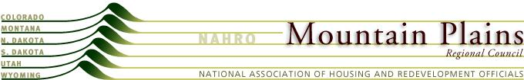

Mountain Plains NAHRO

Resolution
Supporting the Expansion of the MTW program
February 2014
WHEREAS, budget pressures involving administrative and operational funds continue to strain the effective delivery of housing and community development services; and
WHEREAS, the need to deregulate the housing and community development industry has never been greater; and
WHEREAS, despite many opportunities to take decisive action, HUD has failed to do anything that productively lessens the regulatory burden;
NOW THEREFORE BE IT RESOLVED that the Mountain Plains Regional Council supports the reauthorization and broad-based expansion of the Moving to Work (MTW) demonstration in a manner that protects existing MTW agreements while providing a significant number of new MTW agencies with financial flexibility and the freedom to pursue innovative policies.

