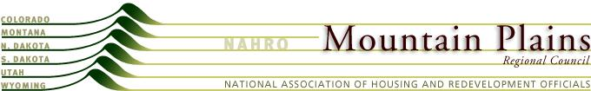

Mountain Plains NAHRO

Resolution
Requesting Expansion of PD Curriculum
February 2014
WHEREAS, NAHRO seeks to be the primary deliverer of professional development products to its member agencies; and
WHEREAS, Mountain Plains agency members are increasingly diversifying into new product areas which is causing their training needs to expand; and
WHEREAS, MPRC members would like to direct their training dollars to NAHRO’s training programs;
NOW THEREFORE BE IT RESOLVED that the Mountain Plains Regional Council asks the Professional Development Committee to explore expedited options to sponsor or provide the Low Income Housing Tax Credit compliance certification course (required by most Housing Credit allocators) and training on the frequent changes to the Multifamily HUD Handbook 4350.

