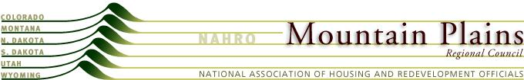

Mountain Plains NAHRO

Resolution
Requesting Regional License of Commissioner Training
March 2014
WHEREAS, NAHRO seeks to be the primary deliverer of professional development products to its member agencies; and
WHEREAS, Mountain Plains agency commissioners volunteer in very rural and remote areas in the states of Montana, Colorado, North Dakota, South Dakota, Wyoming and Utah; and
WHEREAS, MPRC members would like to direct their training dollars to NAHRO’s training programs;
NOW THEREFORE BE IT RESOLVED that the Mountain Plains Regional Council asks the Professional Development Committee to grant the option to expand the Colorado State license for Commissioner Training to a Regional License. Precedent for this request has been established with the Pacific North West Region.

